Data Analysis of Real Estate Market in Different Suburbs in South Australia

Group Members: Jordan Kane, Van Hoang, Isha Sharma & Magdalene Singh

# Overview

The objective of this data analysis project is to examine the real estate market in different suburbs of South Australia using the dataset provided by the South Australian Government's Data Portal <https://data.sa.gov.au/data/dataset/metro-median-house-sales> . The dataset contains information on median house sales prices in various suburbs over a period of time. By analysing this data, we aim to gain insights into the trends and patterns affecting the housing market in different suburbs of South Australia before and after COVID 19.

# Objectives

1. **Suburb Comparison:** Compare and contrast the median house sales prices in different suburbs to identify high-performing and low-performing areas.
2. **Trends over Time:** Analyse the trends in median house sales prices over time to understand the overall market trajectory in South Australia before and after COVID 19.
3. **Correlation with Factors:** Explore the potential correlation between house prices and other factors such as location of the suburbs.

# Data Source

The primary data source for this analysis will be the dataset provided by the South Australian Government's Data Portal <https://data.sa.gov.au/data/dataset/metro-median-house-sales>. The dataset includes historical records of median house sales prices in different suburbs in South Australia.

# Methodology

1. **Data Collection:** The first step will involve collecting the dataset from the provided website.
2. **Data Cleaning:** Perform necessary data cleaning steps such as handling missing values and cleaning unnecessary data.
3. **Exploring Data:** Conduct exploratory data analysis to gain initial insights into the dataset and visualize trends.
4. **Suburb Comparison:** Compare median house sales prices in different suburbs using statistical measures and visualization techniques. Identify top-performing and underperforming suburbs.
5. **Correlation Analysis:** Investigate potential correlations between house prices and other factors, such as locations of the suburbs.
6. **Insights:** Summarize the findings from the analysis and provide insights to stakeholders in the presentation.

The Data Cleaning Jupyter Notebook includes the steps by steps of Data Collection, Data Cleaning and Exploring Data steps listed below. The Data Cleaning Notebook is using Python Pandas coding to combine data from the downloaded csv files, clean the data, and ensure the final data combinations are reliable for analysis. The Data Analysis and Visualisation Jupyter Notebook includes plotting processing and visualising data.

# Research questions

The project main question is “Has the price of housing in the Adelaide suburbs changed since before and after COVID?”

# Data Analysis and Visualisation

## Eastern Suburbs

Jordan Kane

### “Has the number of house sales in Norwood and Burnside changed from 2018-2022?”

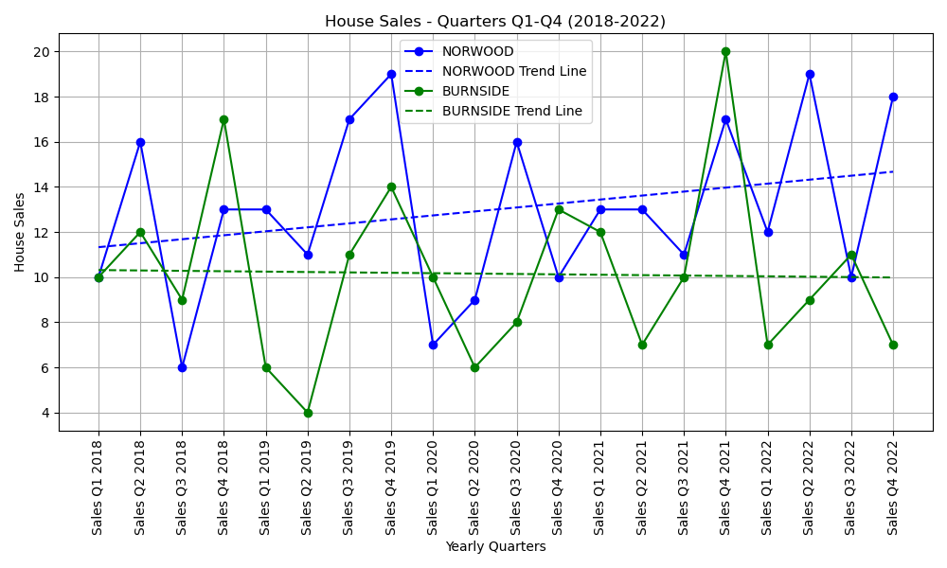

In looking at the line plot comparing House Sales with Yearly Quarters, we can see two separate trendlines for the two selected suburbs. Norwood’s house sales are on a steady increase from 2018-2022 whereas Burnside’s are on a slight decrease. In seeing these trendlines, we might expect to see similar trends for the two suburb’s median house prices as perhaps if a suburb is selling more houses, house prices may begin increasing due to the suburb’s popularity?

### “Has the median house price in Norwood and Burnside changed from 2018-2022?”

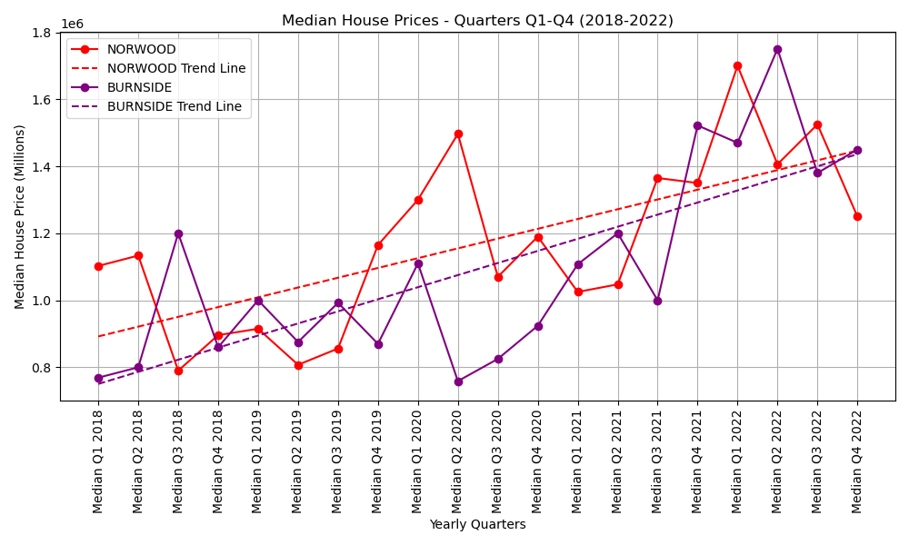

Both suburbs have sharp increases in median house price from 2018-2022, and even though Burnside’s house sales are on a slow decline, their median house price is increasing at a faster rate than Norwood, to a point where Burnside’s median house price was around $100,000 cheaper than Norwood’s at the start of 2018, and by the end of 2022 they were the same, at between 1.4 and 1.5 million dollars.

### “Has the number of house sales impacted the median house price in Norwood and Burnside from 2018-2022?”

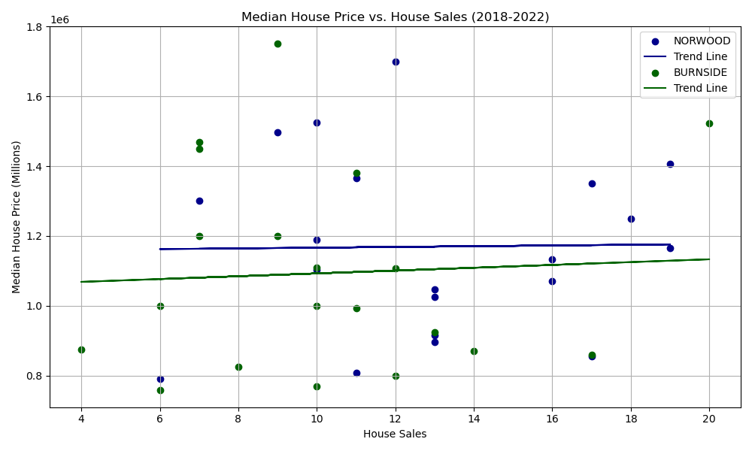

Looking at the scatter plot, we can see that the trendlines are quite flat. Norwood’s trendline is completely flat, meaning that the number of house sales in Norwood does not affect the median house price. In Burnside, the trendline has a very slight increase, but the increase is too small to say that the number of house sales affects the median house price in Burnside.

What this means is that the number of house sales does not play a crucial role in the median house price of Norwood and Burnside and that the increase in median house price in both suburbs post-COVID is likely due to other outside factors.

## Southern Suburbs

Van Hoang

The suburbs of southern area include Goodwood, Edwardstown, Pasadena and Flagstaff Hill. The selection of suburbs for analysis adheres to a linear trajectory extending southward from the CBD, roughly encompassing distances of 1, 5, 10, and 20 kilometers from the CBD, respectively.

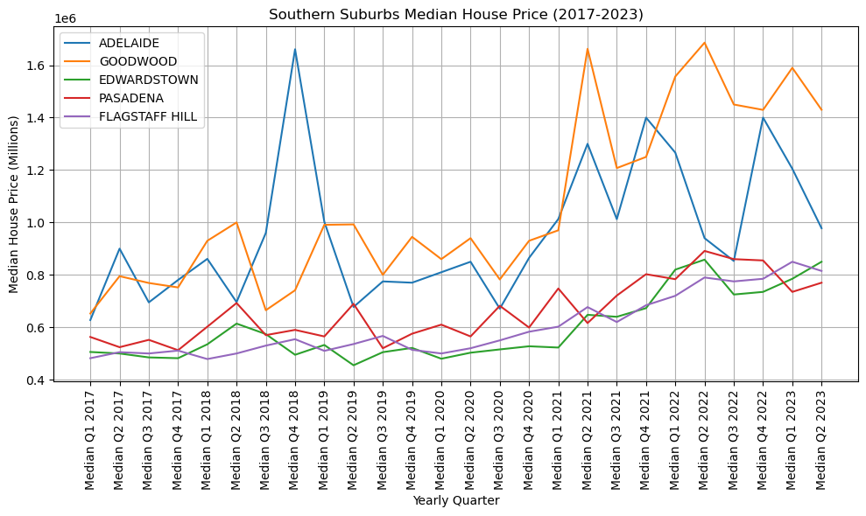

When we examine the median house prices in selected suburbs in comparison to Adelaide CBD, it becomes apparent that both Goodwood and Adelaide started at similar price points in 2017. However, during 2019 and 2020, Goodwood gained a slightly higher price advantage over Adelaide. Notably, a significant leap occurred in Quarter 1 of 2021, propelling Goodwood's median house price from 1 million to 1.7 million. While there are instances in 2022 and 2023 where Goodwood and Adelaide share similar median house prices, the overall trend clearly demonstrates that Goodwood's housing market consistently holds a higher position than that of Adelaide. Among Pasadena, Edwardstown, and Flagstaff Hill, it appears they share the same trend line, with Pasadena having a slightly higher median house price from 2018 to 2022. However, it has slightly dipped below Flagstaff Hill and Edwardstown in the first two quarters of 2023.

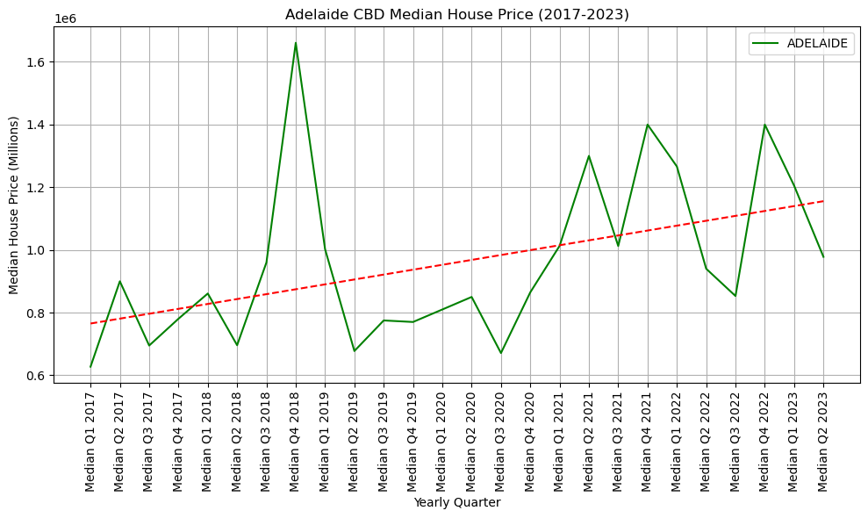

The graph illustrates the Adelaide CBD Median House Price for each quarter from 2017 to 2023, with the x-axis representing the yearly quarters and the y-axis indicating the Median House Price. The highlight is the fourth quarter of 2018, where the median house price in Adelaide CBD reached 1.7 million dollars, signifying a substantial increase from the average of $800,000 in 2017. Following this notable spike, prices started to decrease in 2019, returning to pre-spike levels, until the impact of COVID-19 in 2020 brought the median house price down in Quarter 3. However, this decline was short-lived. The stability of the market within the CBD allowed the median house price to begin a recovery in quarter 4 2020, reaching a new record of 1.4 million dollars in both Quarter 4 of 2021 and Quarter 4 of 2022. The trend line on the graph indicates that the median house price in Adelaide CBD is close to 1.2 million dollars in 2023.

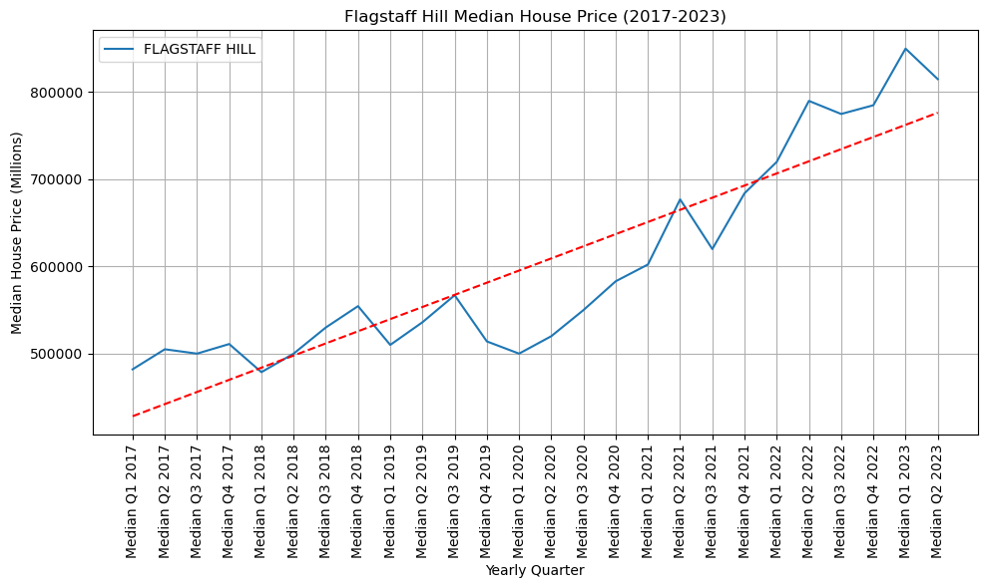

This graph presents a slight variation from the CBD pattern, the impact of COVID-19 in 2020 manifested during Quarter 4 of 2019 and Quarter 1 of 2020. Subsequently, the market exhibited a gradual and steady recovery, ultimately leading to a median house price of approximately 800 thousand dollars in 2023. Notably, this represents a remarkable price increase for Flagstaff Hill from 550 thousand dollars before the onset of COVID-19, marking a notable progression over the span of four years."

## Western Suburbs

Magdalene Singh

All 3 Western suburbs analysed are within a 10 km radius of the Adelaide CBD.

The data looks clean. Visually, we could not see any anomalies. We have determined from the graphs that the property prices and sales have been buoyant throughout the 6½ years with minor peaks and troughs.

### “Have the median house prices in Findon, Grange and Seaton changed from 2017-2023?”

The trend lines in the graph below, indicate that median house prices for all 3 suburbs are increasing on average.

Out of the 3 selected suburbs, Grange has experienced the highest price appreciation over the past 6½ years. There was a significant increase in the median price for this suburb, starting off at $762.5k in 2017 and ending off in the 2nd quarter of 2023 at almost $1.2m.

Findon and Seaton maintained steady and consistent price increases, starting off in 2017 at $512.5k and $525k respectively and ending off at $780.7k and $785k respectively. Both suburbs were almost on par, increasing gradually.

Median prices in these 3 suburbs started dropping from the 1st quarter of 2021, with Grange declining by $200k. However, prices started increasing again in Q3 of 2022, despite the RBA increasing its cash rate from May 2022.



Without more relevant data, we are unable to determine the causes for the peaks and troughs in the median prices.

### “Have the number of house sales in Findon, Grange and Seaton changed from 2017-2023?”

Sales appear to have been unimpacted by COVID lockdowns. The graph shows that there are numerous peaks and troughs in the number of houses sold in the last 6½ years and the trend lines are showing a gradual increase in the number of houses sold.

Seaton had the highest number of sales with the greatest number of dwellings (refer to screenshots below from the Australian Bureau of Statistics), followed by Findon then Grange.

An increase in the number of houses sold would drive an increase in the price of houses as demand increases and supply falls short.

A point to consider here would be new housing developments e.g. larger blocks of land being subdivided; this would increase the number of house sales. Without more relevant data, we are unable to determine the causes for the peaks and troughs in the number of houses sold.

The 3 snapshots appended below, of the census run in 2021, were obtained from the Australian Bureau of Statistics, to determine the density of each suburb. Seaton had the highest number of dwellings. The graphs indicate that Seaton also had the greatest number of sales between the 3 suburbs.

**Without more relevant data, we are unable to determine what factors have impacted the housing market in South Australia or whether COVID-19 has impacted property pricing trends in South Australia.**

## Northern Suburbs

*Van Hoang*

### How the median house price in selected Northen Suburbs changed from 2017 to quarter 2 2023?

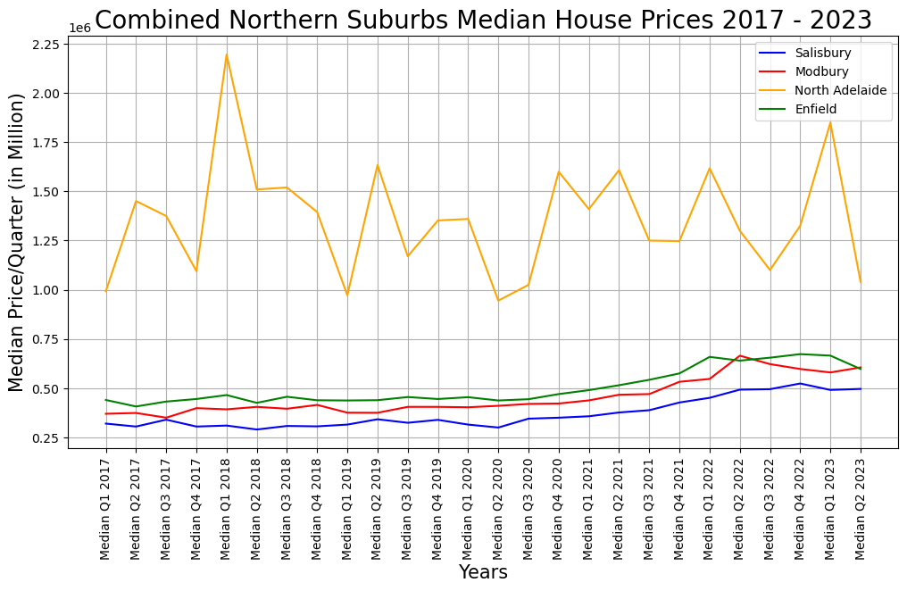

For the analysis of the northern suburbs, we will examine North Adelaide, Enfield, Modbury, and Salisbury. These suburbs are arranged in increasing distances from the CBD. Given that North Adelaide is adjacent to the CBD, we can anticipate higher prices. Enfield is slightly closer to the CBD compared to Modbury, resulting in a higher price as well. However, from 2022 to 2023, the house prices in Modbury are catching up with Enfield. Salisbury is the farthest suburb in this analysis, suggesting that it likely has the most affordable house prices among the others.

### How the number of sales in selected Northen Suburbs from 2017 to quarter 2 2023?

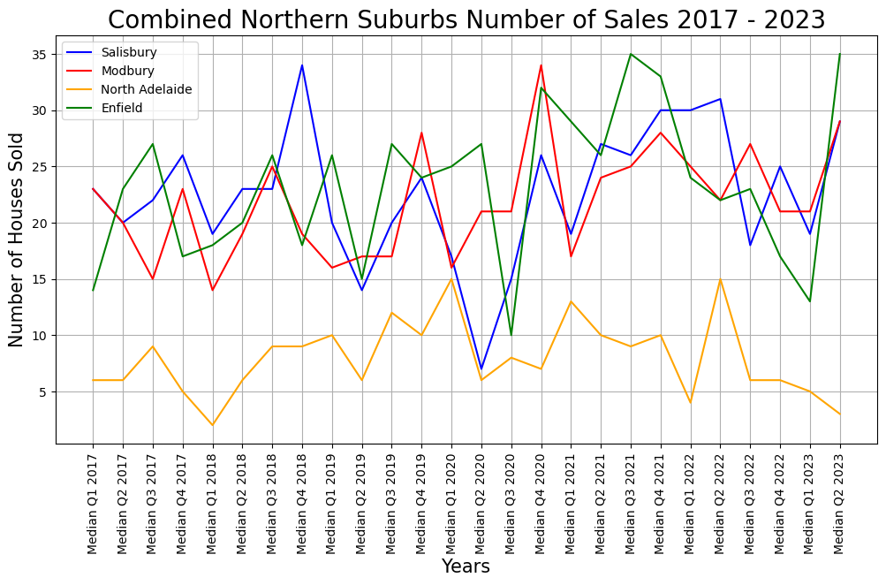

When we examine the number of sales between these suburbs, we notice that North Adelaide has the lowest number of houses sold from 2017 to 2023. This is understandable as they are more expensive compared to the other three suburbs, which have higher sales due to being more affordable.

# CONCLUSION

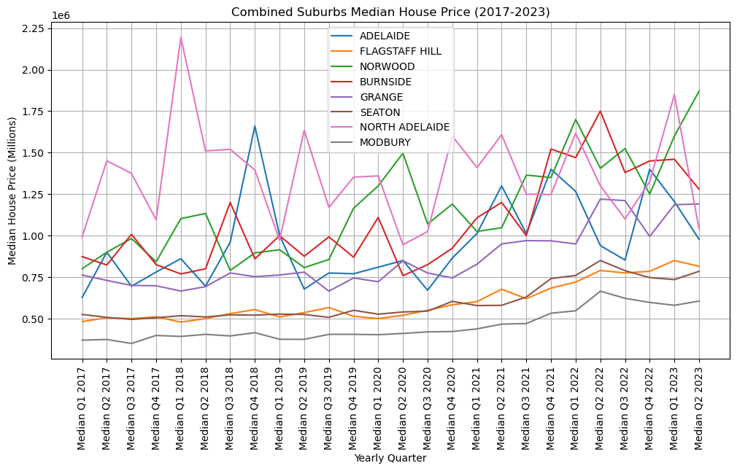

In conclusion, Modbury stands out with the most affordable median house price, followed by Seaton and Flagstaff Hill. On the whole, North Adelaide and Norwood are positioned at the highest median house price level in our analysis. Although Burnside has experienced a decline from its peak, it still maintains a higher price point compared to Adelaide and Grange.

# REFERENCE:

Australian Bureau of Statistics, 2021 Census All Persons QuickStats, Available at: <https://abs.gov.au/census/find-census-data/quickstats/2021/SAL40534>